What are sealants?

Sealants are thin, plastic coatings painted on the surfaces of the back teeth (molars).

Why would my child need sealants?

The most important reason for getting sealants is to avoid cavities. Most cavities happen in a tooth’s pits and grooves.

Fluoride in toothpaste and drinking water protects the smooth surfaces of the teeth but pits and grooves need extra protection.

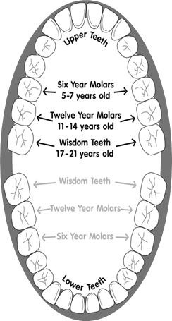

Sealants cover the chewing surfaces of the back teeth to keep out germs and bits of food.

Germs and food get stuck in pits and grooves.

Sealants are brushed onto the surface.

Sealants dry and protect teeth.



Brushing can’t clean the pits well enough.



**Putting** sealants put on the teeth **to prevent cavities** saves time and money in the long run by avoiding the need for fillings and caps.

Why do back teeth decay so easily?

The chewing surfaces of back teeth are rough and uneven because they have small pits and grooves. Food and germs can get stuck in the pits and grooves and stay there a long time because a toothbrush can’t easily brush them away.

Should my child get sealants?

Your child should get sealants on their adult molars as soon as the teeth come in, before cavities attack these teeth.

The first adult molars come in when a child is 5–7 years old. The second adult molars come in when a child is 11–14.

We may recommend sealants for baby teeth if these teeth have deep pits and grooves.



Sealants should be put on teeth after the back teeth come in, before cavities have a chance to start.

How are sealants put on?

Getting sealants put on is simple. Sealants are painted on as a liquid and quickly harden to form a shield over the tooth.

How long do sealants last?

Sealants can stay on for years if they are checked by a dentist. But they need to be checked at regular dental visits to make sure they aren’t chipped or worn away. The dentist or dental hygienist can repair them by adding more sealant.

Does insurance pay for sealants?

Some health insurance programs pay for sealants. Check with your state Medicaid program or your insurance company for details.

For more information, please call your child’s dentist.