Supplementary Materials

Supplementary Figures
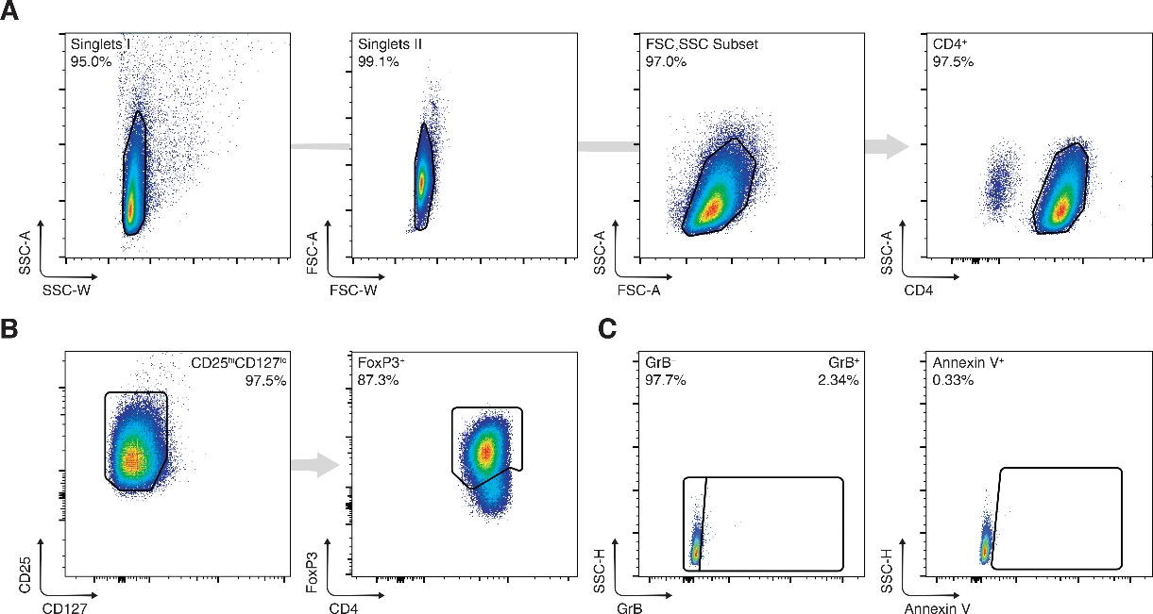
Figure S1 Magnetic-activated CD4⁺CD25⁺CD127⁻ cell sorting purity of human T_{regs}. (A to C) Isolation purity of magnetically sorted CD4⁺ (A) CD25^{hi}CD127^{lo} FoxP3⁺ (B) human T_{regs} with granzyme B and annexin V expression levels (C) immediately post isolation. GrB, granzyme B.
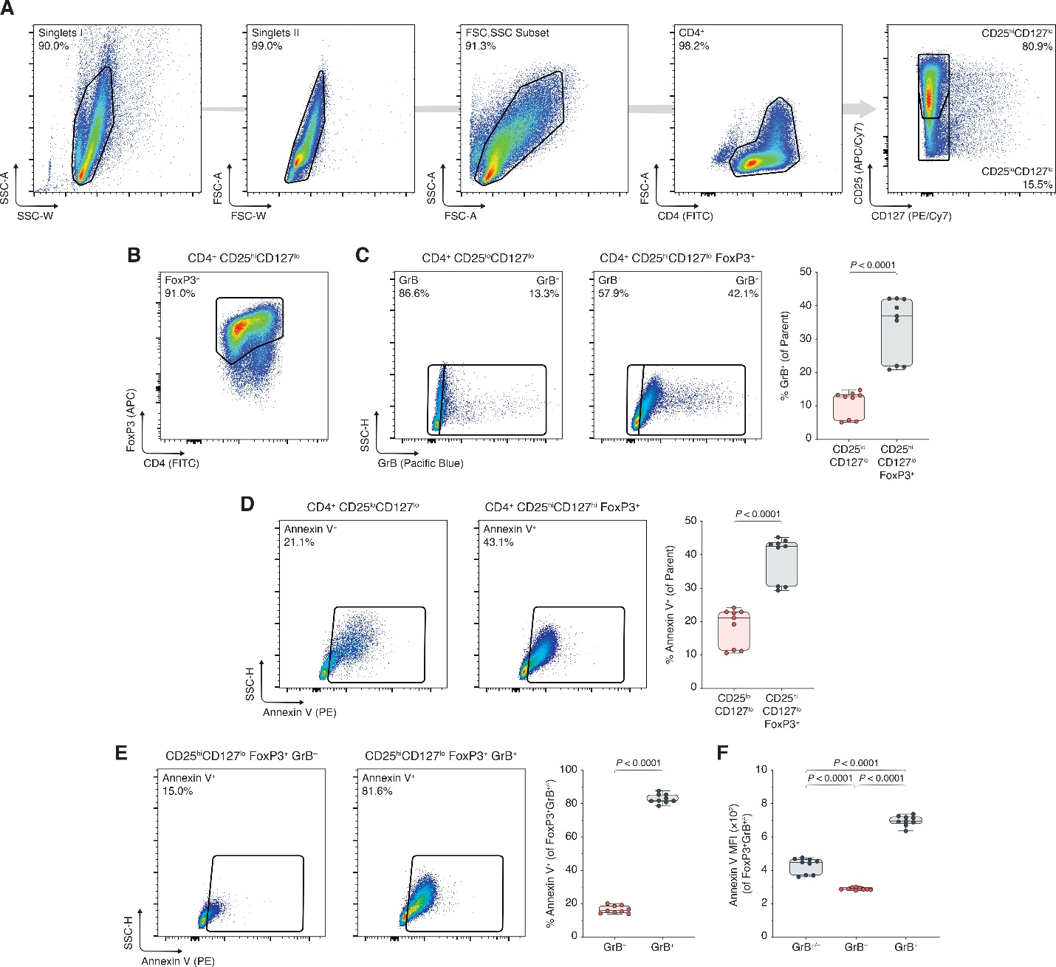
Figure S2 Human T_{reg} phenotyping strategy and activation-induced upregulation of GrB and apoptosis. Human T_{regs} were isolated and expanded for three days with α-CD3, α-CD28, and IL-2 (n = 3 technical replicates/condition; 3 representative experiments). (A to B) Gating strategy identifying magnetically sorted, activated human CD4⁺ CD25^{hi}CD127^{lo} T cells (A), and therein the FoxP3⁺ subset (B). (C) Flow cytometric analysis of GrB⁺ cells among the CD4⁺ CD25^{lo}CD127^{lo} T cell and CD4⁺ CD25^{hi}CD127^{lo} FoxP3⁺ T_{reg} subsets and accompanying box plots. (D) Flow cytometric analysis and box plots of Annexin V⁺ cells among the CD4⁺ CD25^{lo}CD127^{lo} T cell and CD4⁺ CD25^{hi}CD127^{lo} FoxP3⁺ T_{reg} subsets. (E) Flow cytometric analysis of Annexin V⁺ cells among GrB⁻ and GrB⁺ FoxP3⁺ T_{reg} subsets, including box plots. (F) Box plots of Annexin V MFI among total GrB (GrB^{+/-}), GrB⁻, and GrB⁺ FoxP3⁺ T_{reg} subsets. Data represent boxplots with median, interquartile range, minimum, maximum, and all individual data points of the denoted experimental groups. P values were calculated with independent samples two-tailed Student’s t-tests, and non-parametric Mann-Whitney U-tests were performed when the assumption of homoscedasticity could not be met. For analyses with more than two groups, one-way analyses of variance followed by Holm-Šídák multiple comparison tests were performed. GrB, granzyme B; MFI, mean fluorescence intensity.
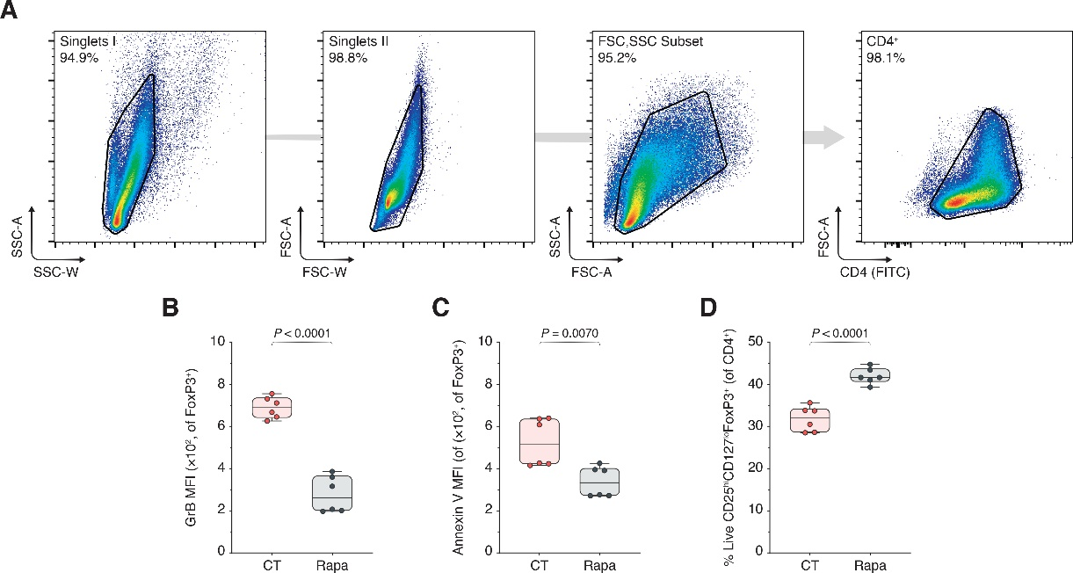
Figure S3 Rapamycin experiments phenotyping strategy and supplementary box plots related to figure 1. (A) Gating strategy identifying magnetically sorted, activated human CD4⁺ T cells. (B to D) Box plots of GrB (B) and Annexin V (C) mean fluorescence intensities (MFIs), and percentages of live Annexin V⁻ CD25^{hi}CD127^{lo} FoxP3⁺ T_{regs} (D) among CD4⁺ T cells (n = 3 technical replicates/condition; 2 representative experiments of 5). Data represent boxplots with median, interquartile range, minimum, maximum, and all individual data points of the denoted experimental groups. P values were calculated with independent samples two-tailed Student’s t-tests, and non-parametric Mann-Whitney U-tests were performed when the assumption of homoscedasticity could not be met. CT, control; GrB, granzyme B; MFI, mean fluorescence intensity; Rapa, rapamycin.
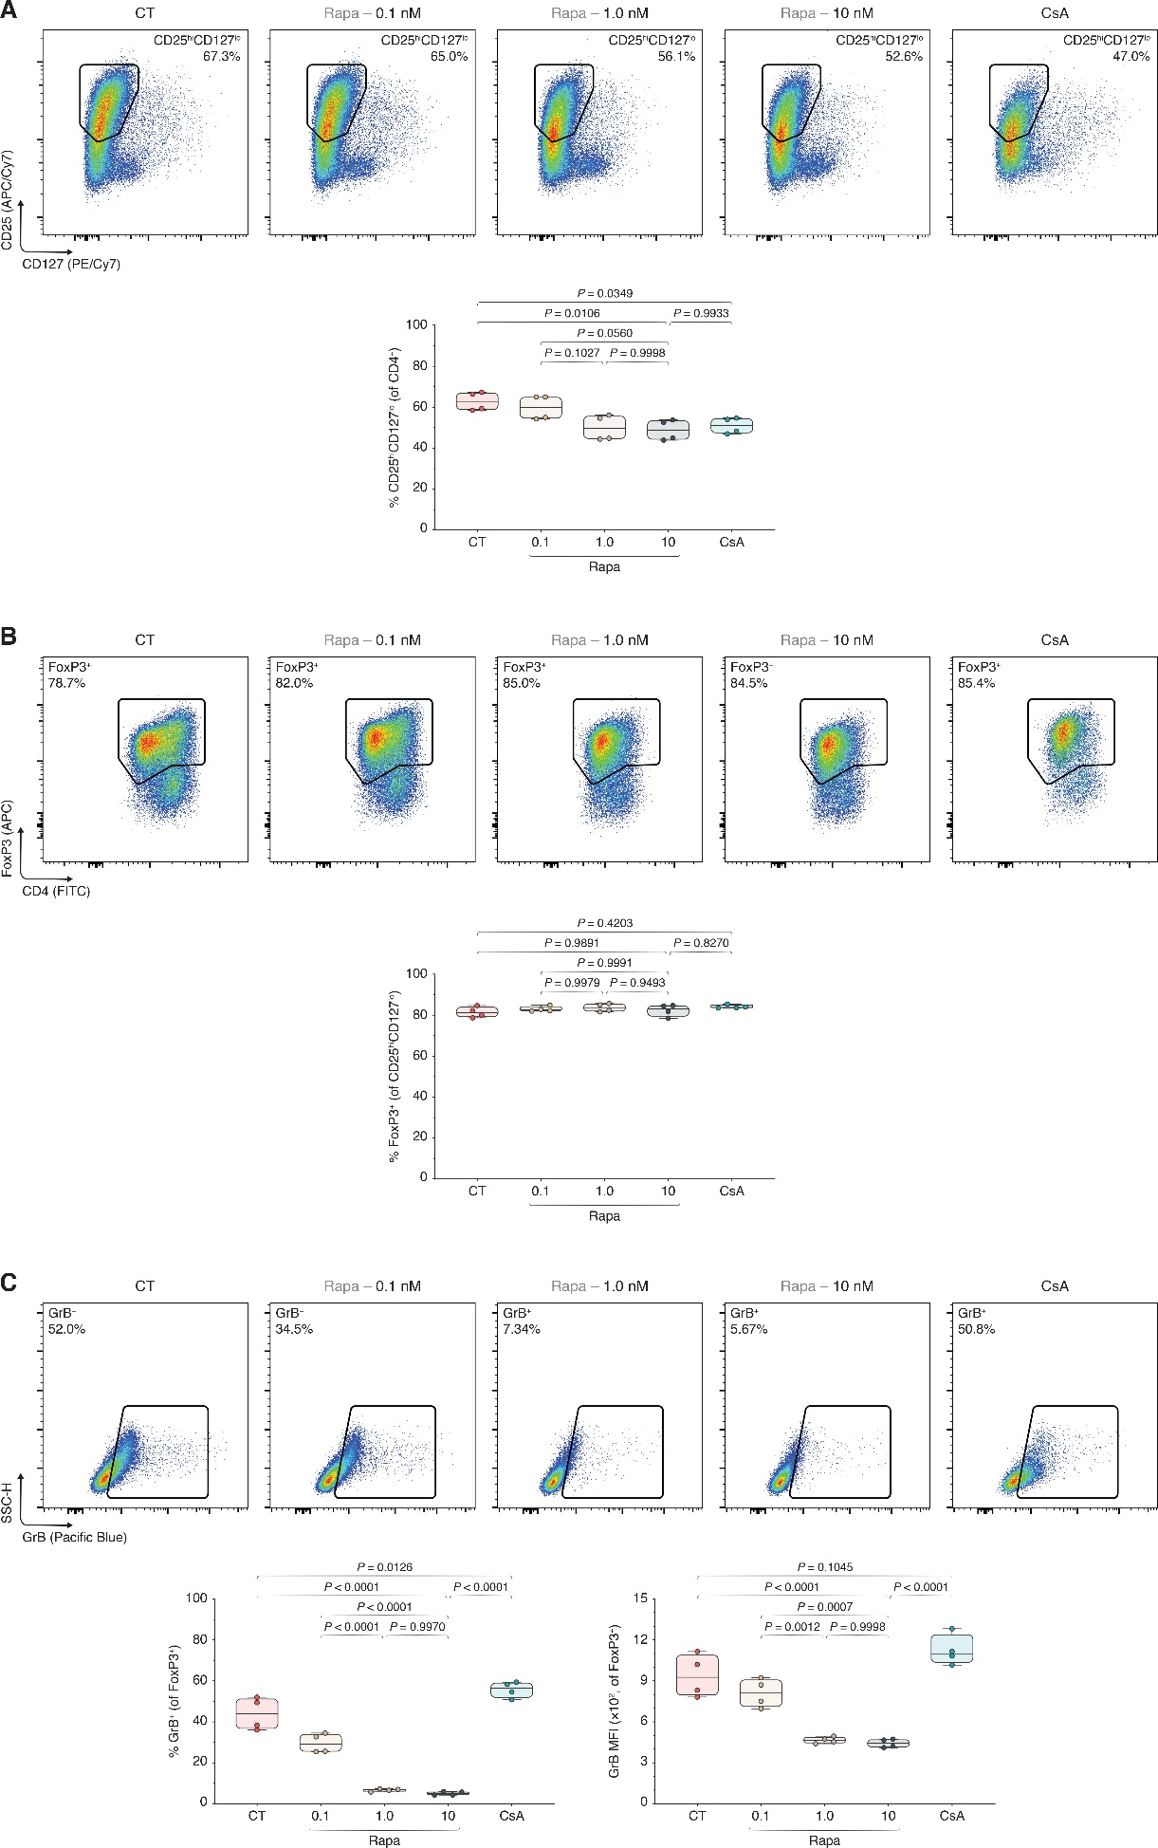
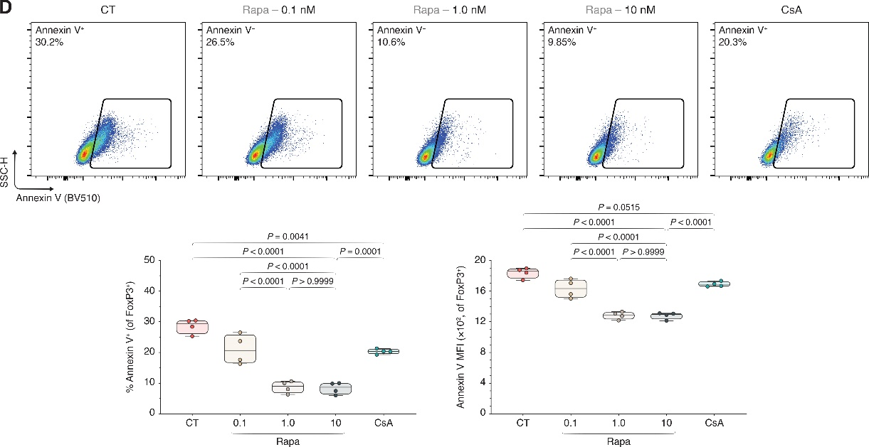
Figure S4 Rapamycin dose de-escalation increases GrB expression and apoptosis in human T_{regs} and affects T_{reg} viability discordantly from calcineurin inhibition. Human T_{regs} were isolated and expanded for three days with α-CD3, α-CD28, and IL-2, without additional inclusions (CT), with CT stimulants plus 0.1–10 nM rapamycin (Rapa), or with CT stimulants and cyclosporin A (CsA). (A to D) Flow cytometric analyses of CD25^{hi}CD127^{lo} subset among CD4⁺ T cells (A), FoxP3⁺ subset among CD25^{hi}CD127^{lo} cells (B), and GrB⁺ (C) and Annexin V⁺ subsets (D) among FoxP3⁺ T_{regs}, including the respective box plots (n = 2 technical replicates/condition; 2 experiments). Data represent boxplots with median, interquartile range, minimum, maximum, and all individual data points of the denoted experimental groups. P values were calculated with one-way analyses of variance followed by Holm-Šídák multiple comparison tests. CsA, cyclosporin A; CT, control; GrB, granzyme B; MFI, mean fluorescence intensity; Rapa, rapamycin.
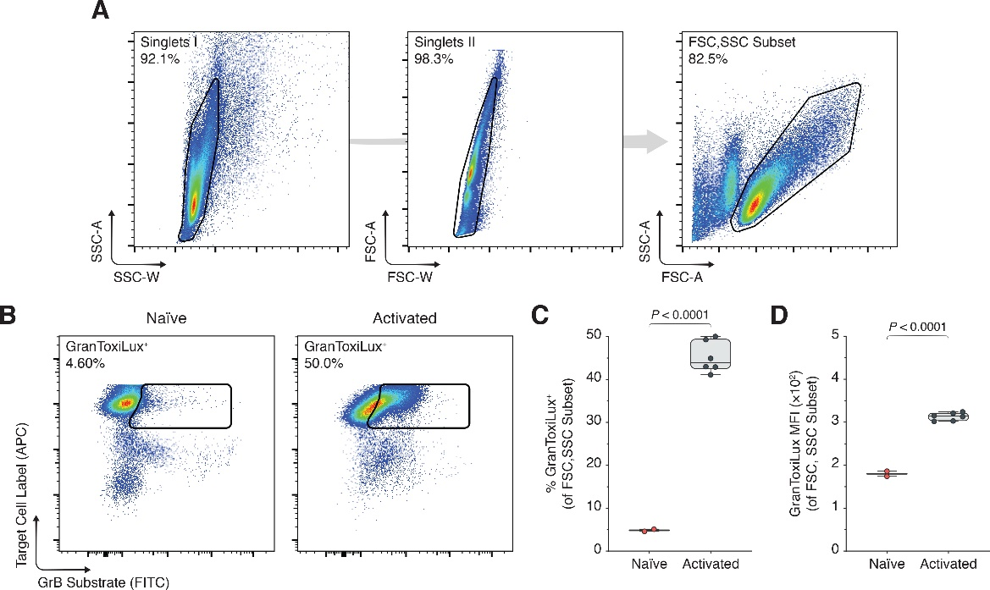
Figure S5 GranToxiLux experiments phenotyping strategy and T_{reg} stimulation leads to intracytoplasmically active GrB. (A) Gating strategy identifying an active FSC^{hi}SSC^{hi} subset of magnetically sorted CD4⁺ CD25^{hi}CD127^{lo} human T_{regs} that were expanded for three days with α-CD3, α-CD28, and IL-2. (B to D) Flow cytometric analysis and box plots of GranToxiLux⁺ T_{reg} percentages (B and C), and GranToxiLux mean fluorescence intensities (E; n = 3 technical replicates/condition; 2 representative experiments of 4). Data represent boxplots with median, interquartile range, minimum, maximum, and all individual data points of the denoted experimental groups. P values were calculated with independent samples two-tailed Student’s t-tests, and non-parametric Mann-Whitney U-tests were performed when the assumption of homoscedasticity could not be met. GrB, granzyme B; MFI, mean fluorescence intensity.
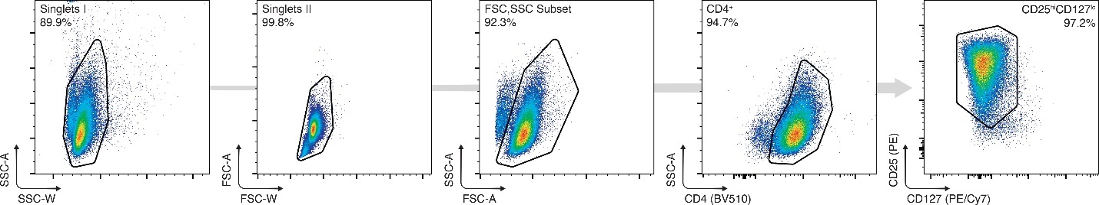
Figure S6 Phosphorylation experiments phenotyping strategy. Gating strategy identifying magnetically sorted CD4⁺ CD25^{hi}CD127^{lo} human T_{regs} that were expanded in a 24-hour cell culture window with α-CD3, α-CD28, and IL-2.
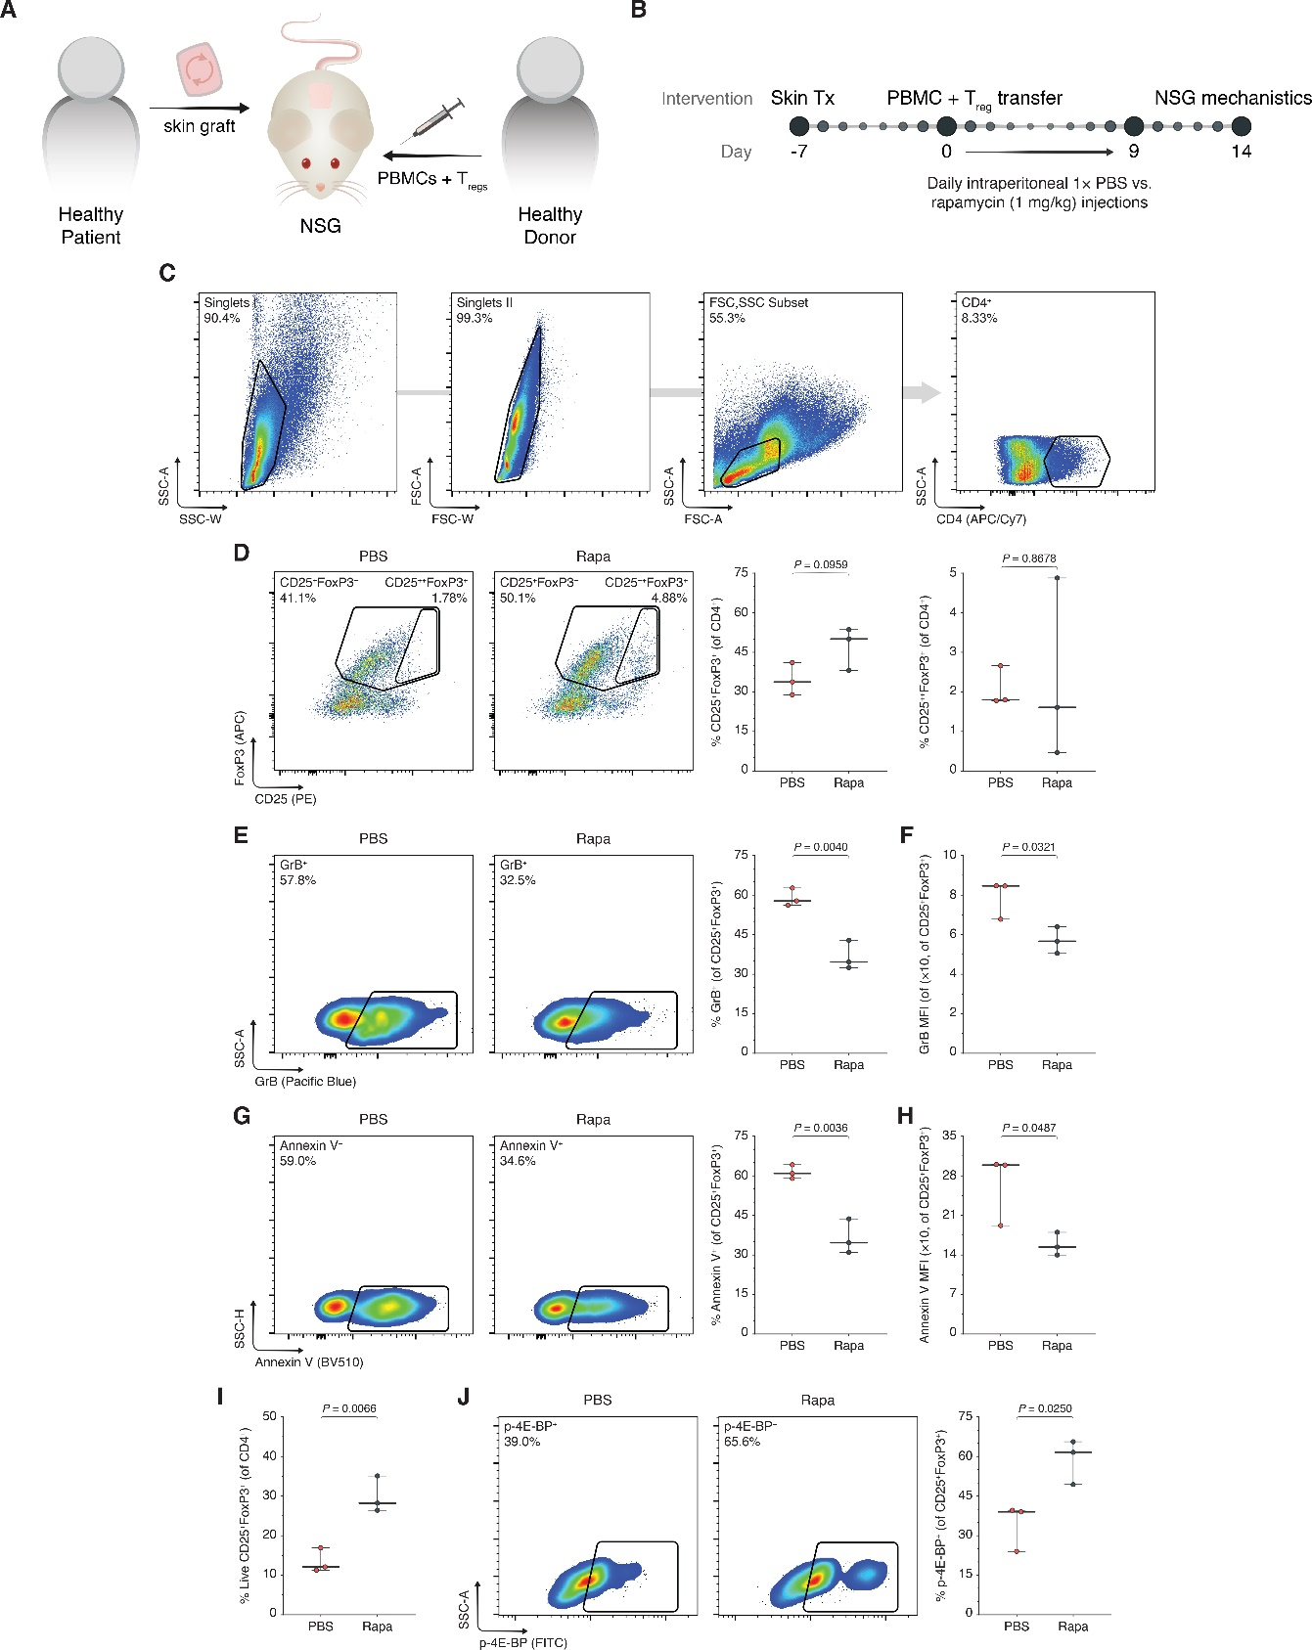
Figure S7 In vivo mTORC1 inhibition reduces human T_{reg} GrB expression apoptosis of peripheral T_{regs} in an in vivo allotransplantation model. (A and B) NOD-scid IL-2 receptor-γ^{null} (NSG) mice were transplanted with healthy donor skin seven days prior to the adoptive transfer of 5.0×10⁶ human PBMCs and 1.0×10⁶ human CD4⁺CD25^{hi}CD127^{lo} T_{regs} (A). Afterwards, the NSG mice received daily intraperitoneal injections of 1× DPBS (PBS) or 1 mg/kg rapamycin (Rapa) for nine days. Fourteen days from the start of the treatment, the mice were euthanized and the splenocytes were extracted (B; n = 3 mice/condition; 1 of 2 experiments). (C) Gating strategy identifying splenic CD4⁺ human T cells. (D) Flow cytometric analysis and box plots of CD25⁺FoxP3⁺ and CD25⁺⁺FoxP3⁺ T_{regs} among CD4⁺ T cells. (E and F) Flow cytometric analysis and box plots of GrB⁺ cells among FoxP3⁺ T_{regs} (E), and box plots of GrB mean fluorescence intensities (MFIs) among FoxP3⁺ T_{regs} (F). (G and H) Flow cytometric analysis and box plots of Annexin V⁺ cells among FoxP3⁺ T_{regs} (G), and box plots of Annexin V MFIs among FoxP3⁺ T_{regs} (H). (I) Box plots of live Annexin V⁻ CD25^{hi}CD127^{lo} FoxP3⁺ T_{regs} among CD4⁺ T cells. (J) Flow cytometric analysis and box plots of p-4E-BP⁺ cells among FoxP3⁺ T_{regs}. Data represent boxplots with median, interquartile range, minimum, maximum, and all individual data points of the denoted experimental groups. P values were calculated with independent samples two-tailed Student’s t-tests, and non-parametric Mann-Whitney U-tests were performed when the assumption of homoscedasticity could not be met. GrB, granzyme B; MFI, mean fluorescence intensity; Rapa, rapamycin.

