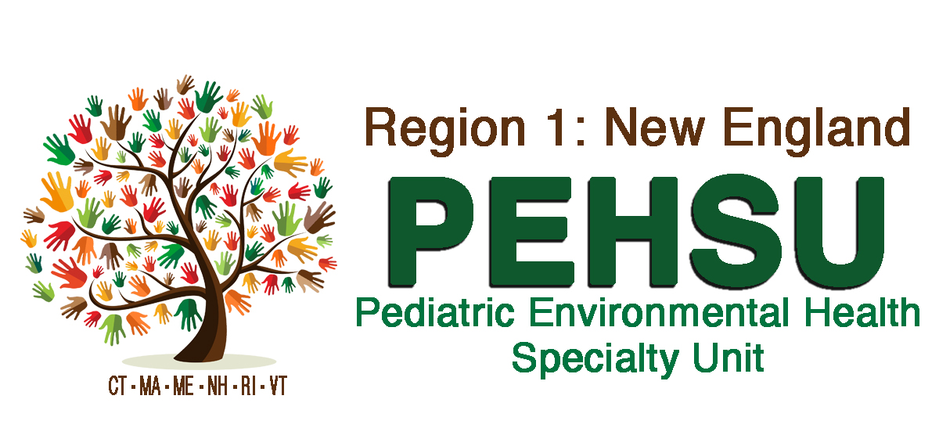
Region 1 New England PEHSU EJCC Scholars Application

APPLICANT INFORMATION
Applicant Name:_____________________________________________________
Is the applicant under the age of 18? Yes or no

Applicant’s School Name: _____________________________________________
Academic Advisor Contact Information:
Name:_______________________________________________________
Phone:______________________________________________________
Email:_______________________________________________________

DOCUMENTATION REQUIRED
- Registrar’s letter (Student)
Student Intern is enrolled in an academic program in which the Department has a signed Educational Program Agreement OR the Student Intern has obtained a letter from the Registrar’s Office or Academic Advisor on school letterhead stating he or she is not on academic probation and in good standing.

- Proof of academic enrollment and internship credit. (Student)
The student internship must be related to a bonafide educational opportunity. Please provide the Degree and Class for which the Student Intern will earn academic credit through this internship. If the internship will not result in academic credit toward a Degree, please provide a letter from the teacher or academic advisor, on school letterhead, detailing how the internship will be beneficial for the Student Intern’s studies. Please submit a statement in writing if the Student Intern is not receiving academic credit.

- Acknowledgements
- The Student Intern understands he or she will not be paid for the internship nor has the Student Intern been promised any job at the end of the internship by any department staff?

- The length of the internship will not exceed the time needed for the Student Intern to benefit from the learning experience?

- The Student Intern will attend all required safety training for the department?

Please sign that you understand and agree to the acknowledgements stated above.
Applicant: _______________________________________ Date:___________
PEH Staff: ______________________________________ Date: ___________

______________________________________________________________________
To be completed upon acceptance into the EJCC Program by PEH Staff
Start Date: ______________________
End Date: _______________________
Reports to (PI): Alan Woolf, MD, MPH
Will they need a badge: YES
If Yes, Location: 333 Longwood Ave
Patient Contact: YES
Research animal contact: NO
Human blood, body fluid, and/or tissue contact: NO

Description of the Project (PEH Staff)
Describe the Student Intern’s assignment and how the Student Intern’s work will not displace the work of paid employees.

