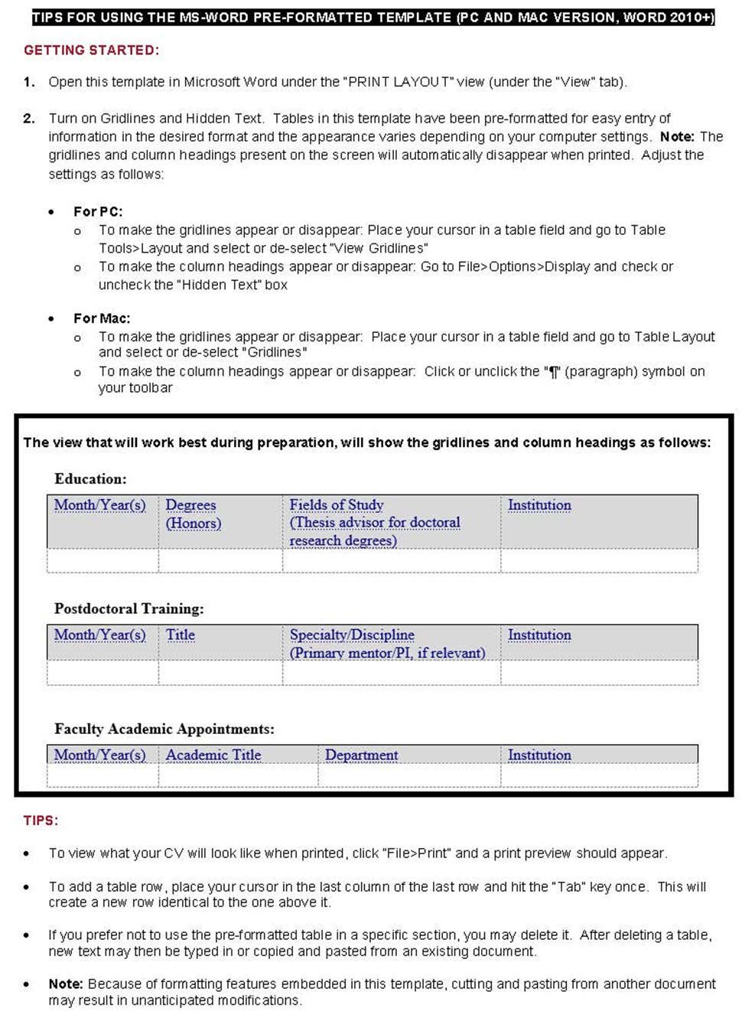
General Instructions for Preparation of the Faculty of Medicine Curriculum Vitae

TIPS FOR USING THE-MS·WORD PRE-FORMATTED TEMPLATE (PC AND MAC VERSION, WORD2010+)

GETTING STARTED:

- Open this template in Microsoft Word under the “PRINT LAYOUT" view (under the "View" tab).
- Turn on Gridlines and Hidden Text. Tables in this template have been pre-formatted for easy entry of information in the desired format and the appearance varies depending on your computer settings. Note: The gridlines and column headings present on the screen will automatically disappear when printed. Adjust the settings as follows:

- For PC:
  - To make the gridlines appear or disappear: Place your cursor in a table field and go to Table>Tools>Layout and select or de-select "View Gridlines"
  - To make the column headings appear or disappear: Go to File> Options>Display and check or uncheck the "Hidden Text" box
- For Mac:
  - To make the gridlines appear or disappear: Place your cursor in a table field and go to Table Layout and select or de-select "Gridlines"
  - To make the column headings appear or disappear: Click or unclick the "¶'' (paragraph) symbol on your toolbar

The view that will work best during preparation, will show the gridlines and column headings as follows:

Education:
Month/Year(s) | Degrees (Honors) | Fields of Study (Thesis advisor for doctoral research degrees) | Institution
Postdoctoral Training:
Month/Year(s) | Degrees (Honors) | Fields of Study (Thesis advisor for doctoral research degrees) | Institution
Faculty Academic Appointments
Month/Year(s) | Degrees (Honors) | Fields of Study (Thesis advisor for doctoral research degrees) | Institution

TIPS:

- To view what your CV will look like when printed, click "File>Print" and a print preview should appear.
- To add a table row , place your curs or in the last column of the last row and hit the "Tab" key once. This will create a new row identical to the one above it.
- If you prefer not to use the pre-formatted table in a specific section, you may delete it. After deleting a table, new text may then be typed in or copied and pasted from an existing document.
- Note: Because of formatting features embedded in this template, cutting and pasting from another document may result in unanticipated modifications.

(Please delete this first page from your final CV)

The Faculty of Medicine of Harvard University
Curriculum Vitae

Date Prepared:

Name:

Office Address:

Home Address:

Work Phone:

Work Email:

Education:

Postdoctoral Training:

Faculty Academic Appointments:

Appointments at Hospitals/Affiliated Institutions:

Faculty Membership in Harvard Initiatives, Programs, Centers, and Institutes

Other Professional Positions:

Major Administrative Leadership Positions:

Local

Regional

National

International

Committee Service:

Local

Regional

National

International

Professional Societies:

Grant Review Activities:

Editorial Activities:
- Ad hoc Reviewer

- Other Editorial Roles

Honors and Prizes:

Report of Funded and Unfunded Projects

Past

Current

Projects Submitted for Funding

Training Grants and Mentored Trainee Grants

Unfunded Current Projects

Report of Local Teaching and Training

Teaching of Students in Courses:

Formal Teaching of Residents, Clinical Fellows and Research Fellows (post-docs):

Clinical Supervisory and Training Responsibilities:

Research Supervisory and Training Responsibilities:

Formally Mentored Harvard Students (Medical, Dental, Graduate, and Undergraduate):

Other Mentored Trainees and Faculty:

Formal Teaching of Peers (e.g., CME and other continuing education courses):
No presentations below were sponsored by 3rd parties/outside entities
Those presentations below sponsored by outside entities are so noted and the sponsor(s) is (are) identified.

Local Invited Presentations:
No presentations below were sponsored by 3rd parties/outside entities
Those presentations below sponsored by outside entities are so noted and the sponsor(s) is (are) identified.

Report of Regional, National and International Invited Teaching and Presentations
No presentations below were sponsored by 3rd parties/outside entities
Those presentations below sponsored by outside entities are so noted and the sponsor(s) is (are) identified.

Regional

National

International

Report of Clinical Activities and Innovations

Past and Current Licensure and Board Certification:

Practice Activities:

Clinical Innovations:

Report of Teaching and Education Innovations

Report of Technological and Other Scientific Innovations

Report of Education of Patients and Service to the Community
No presentations below were sponsored by 3rd parties/outside entities
Those presentations below sponsored by outside entities are so noted and the sponsor(s) is (are) identified.

Activities

Educational Material for Patients and the Lay Community:

Books, articles, and presentations in other media

Educational material or curricula developed for non-professional audiences

Patient educational material

Recognition:

Report of Scholarship

Peer-Reviewed Scholarship in print or other media:

Research Investigations

Other peer-reviewed scholarship

Scholarship without named authorship

Non-peer reviewed scholarship in print or other media:

Reviews, chapters, and editorials

Books/textbooks for the medical or scientific community

Case reports

Letters to the Editor

Other non-peer reviewed scholarship

Professional educational materials or reports, in print or other media:

Local/Unpublished Clinical Guidelines and Reports:

Thesis:

Manuscripts Submitted to Preprint Servers

Abstracts, Poster Presentations, and Exhibits Presented at Professional Meetings:

Narrative Report

General Guidelines
- Do not exceed two single-spaced pages; length is generally commensurate with rank (e.g. ≤ 1-page for Instructors and Assistant Professors)
- Can be optionally organized with subheadings for different topics
- Write in the first person (use “I” statements)
- Avoid jargon; instead, write for a broad audience
- Avoid or limit personal details about your family or health
- Update periodically to account for career growth

Purpose of the Narrative
- Tell a cohesive story about the various aspects of your career
- Describe the impact of your work on the field, with an extension to how it benefits healthcare
- Demonstrate evidence of dissemination of your work
- Convey the ‘big picture’ relevance of your work to non-experts
- Give perspective about the importance of field-specific activities
- Explain events or accomplishments that don’t fit anywhere else
- Anticipate obvious questions about major career shifts or work gaps
- Emphasize your recent and future work, including work in progress

Include contributions to:

- Your Area of Excellence, if applicable (e.g., Clinical Expertise and Innovation; Investigation; Teaching and Educational Leadership).
- Teaching and mentorship (if not already described under your Area of Excellence).
- Any Significant Supporting Activities (Administration & Institutional Service; Clinical Expertise; Education of Patients & Service to the Community; Diversity, Equity & Inclusion; Investigation; Special Merit in Education).

