New users to the Boston Children’s Hospital’s (BCH) Animal Program
1. Obtain a BCH employee ID. Sponsoring department/division administrator for non-BCH staff must submit an Associated Personnel form.

2. When employee ID# is received, department/division administrator must submit an Online Access Request (OAR) form to obtain the following accounts:
- Computer account
- Email
- Animal User Orientation/Brainshark ‘system’ Access

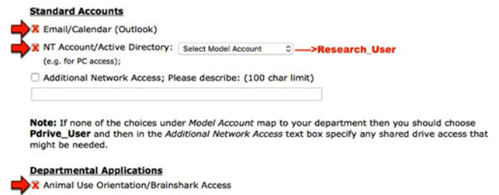

3. After requestor and/or employee is notified by ISD/accounts team that accounts have been set up, send an email to Maggie Swenson or APSA@childrens.harvard.edu to enroll in Animal Use Orientation (AUO). AUO comprises of online curriculum/courses and in person facility tour. Paste the following into an email, complete and send to Maggie or APSA:

**Has your supervisor or department administrator provided you with the following computer access via the Online Access Request form? Please check with supervisor as all three are required prior to submitting this form:

1. BCH Computer Account Username: [ ] Yes
2. BCH email Account: [ ] Yes:
3. Animal Use Orientation/Brainshark [ ] Yes (must be checked off on the OAR form for ISD during onboarding)

Are you a [ ] BCH Employee or an [ ] Associated Personnel?
First Name:
Last Name:
BCH ID #:
BCH Email:
Lab Phone number (cell phone is no lab phone is available):
Species you will be working with:
Building the animals are housed in (Enders or Karp):

4. Employee must also obtain clearance from Occupational Health Services by completing the “Initial Animal Exposure Risk Assessment-Questionnaire” and email to ohs@childrens.harvard.edu. (Note: OHS clearances must be renewed annually - annual renewals are done via the OHS portal online. OHS will notify employees when they are due.)

5. When online Brainshark courses and facility tour are complete and OHS clearance is obtained, PI to submit an Add Staff Request form to Maggie Swenson or APSA@childrens.harvard.edu. Paste the following into an email, complete and send to Maggie or APSA:

Add Staff Request:
1. Name of Staff to be added:
2. Staff member's email address:
3. Protocol number(s):
4. PI:
5. Would you like this individual to have editing/writing privileges for your web-based protocol (Yes/No)?
6. Would you like this individual to be copied on email correspondence for this protocol (Yes/No)?
7. Describe this individual's responsibilities as they relate to the species, animal use and handling, specific procedures and euthanasia as proposed in the protocol. Your submission will be returned if the specific procedures this person will be performing are not listed.
8. Please provide a brief explanation of this individual's experience (number of years) and/or training (other than Animal Use Orientation) with the specific procedures they will be performing. If additional training is needed, please list the names of the individuals responsible for training and a description of the trainers' experience (number of years).
I have provided the individual indicated above with a copy of the protocol and any amendments, and have reviewed their contents with him/her.

6. After add staff request approval, employee submits Animal Facility Access Request to Elizadel Deauna at the Karp Lobby front desk.

